SECTION 3 Keeping the Regulators in Good Playing Condition
The playing of well tuned and balanced regulators against the chanter, using various note combinations, quickly shows the learner what sounds well and what does not. The diagram of chords can help the learner to become familiar with the hand chords. The ultimate objective is to be able to pick out regulator notes applicable to any note played on the chanter. With regular practice and familiarity, gained over a long time, with a set of pipes the player will be able to do this with eyes closed. Thus, after playing any tune through, instinctive regulator accompaniment should be possible to the advanced player.
Figure 1 give examples of hand chords and the best hand and finger positions for sounding these regulator notes whilst playing the chanter
TUNABILITY: When the appropriate reed is to be set in the regulator, it should be positioned so that its top note will be in tune with the corresponding note on the properly tuned chanter. If the regulator has been correctly designed its lower notes will then agree with the corresponding notes on the chanter. If the lower notes are slightly sharper than the chanter then a rush or wire inserted into the regulator will bring it into agreement with the chanter notes. However, the size and amount of rush, wire, winding of waxed thread, blob of blue tack, white tack or plasticine/mala or similar, used to tune lower notes can only be decided after lots of trials, errors and re-adjustments over a long period of time.
See the following
Figure 2 Principle of tuning pipes, chanters and regulators
Figure 3. Middle regulator tuning
Figure 4 Alternative methods of tuning a regulator (other than the thick pointed tuning pin)
Figure 5 The piston method of tuning a regulator

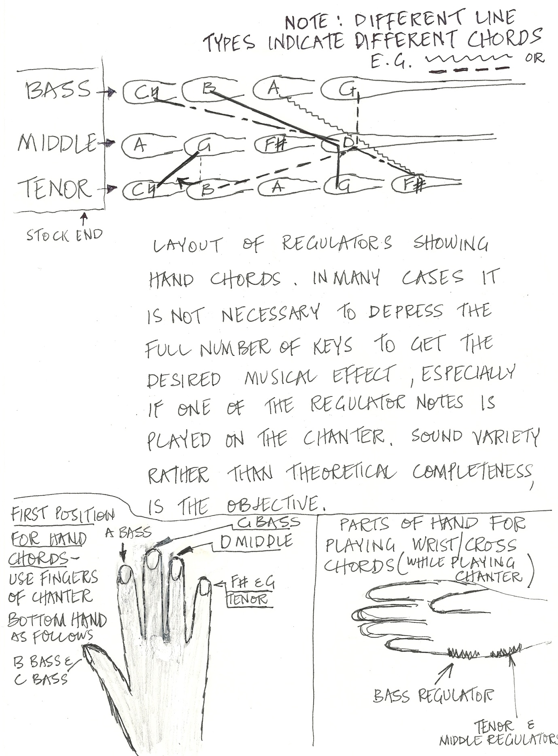

Figure 1

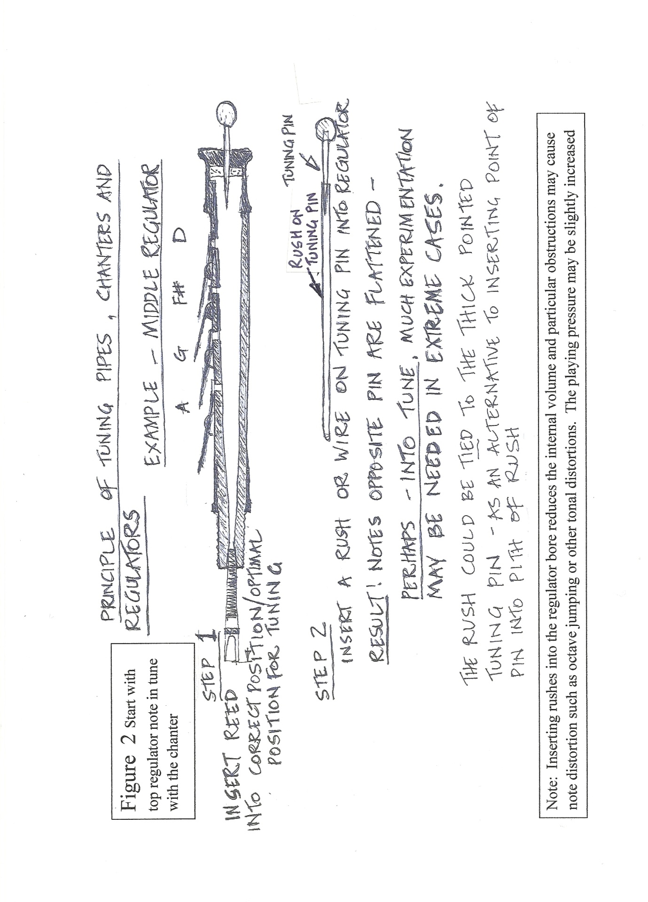

.
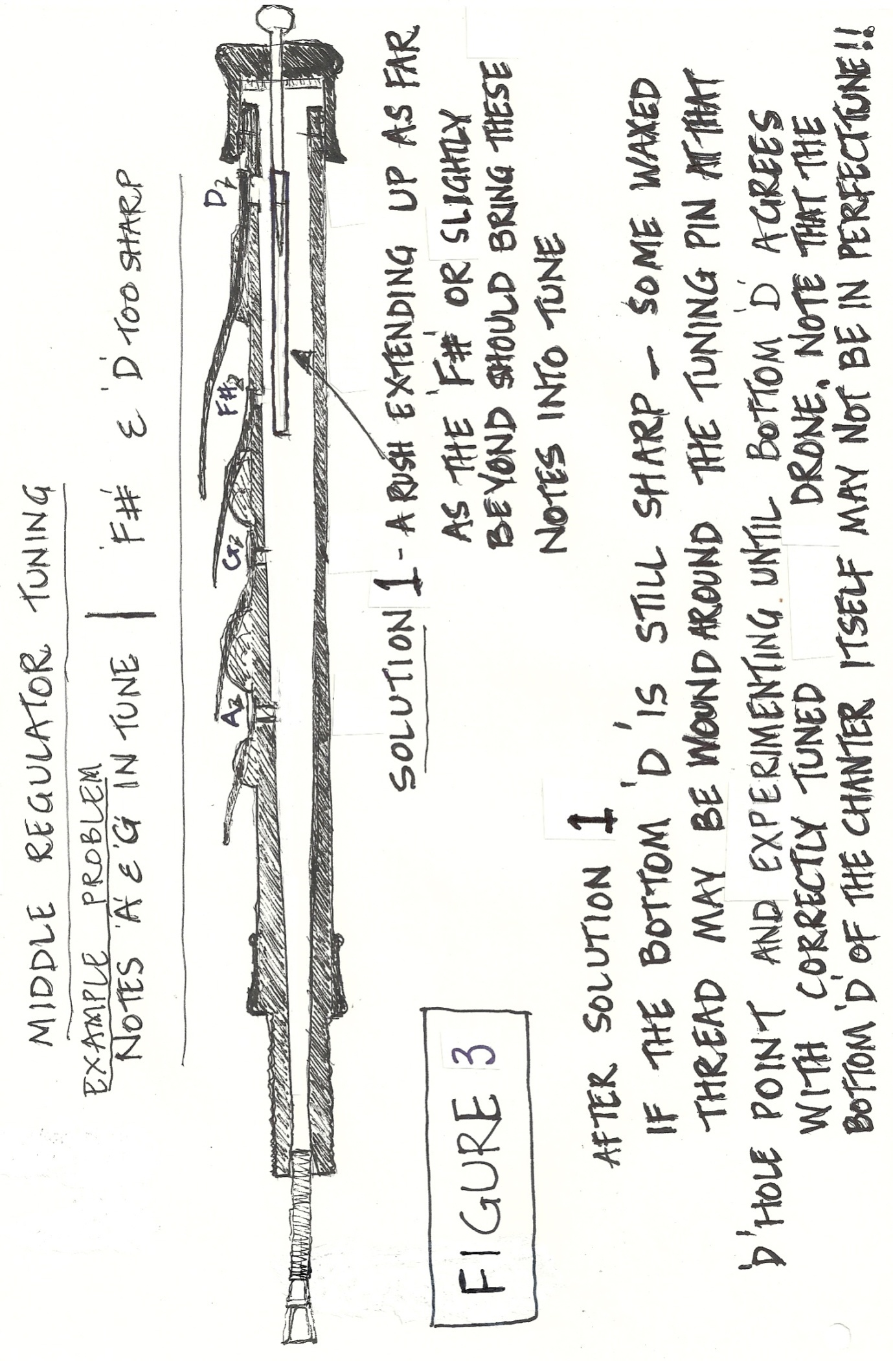
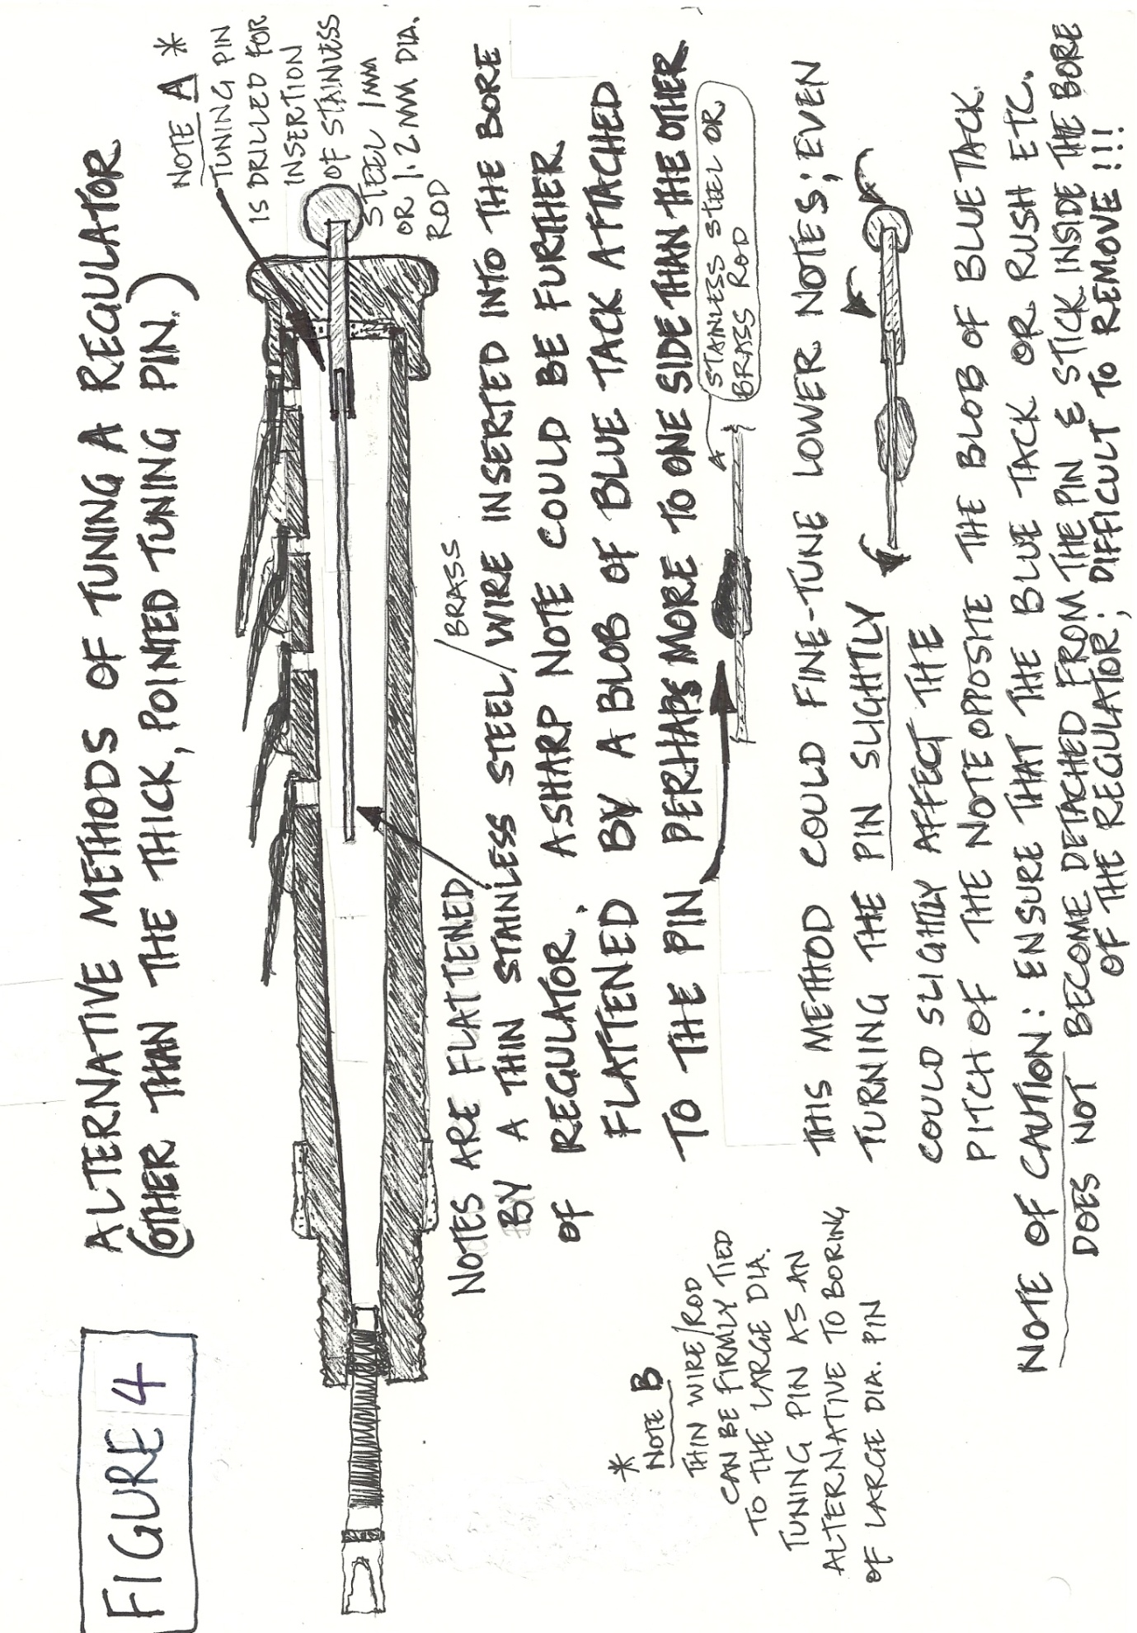

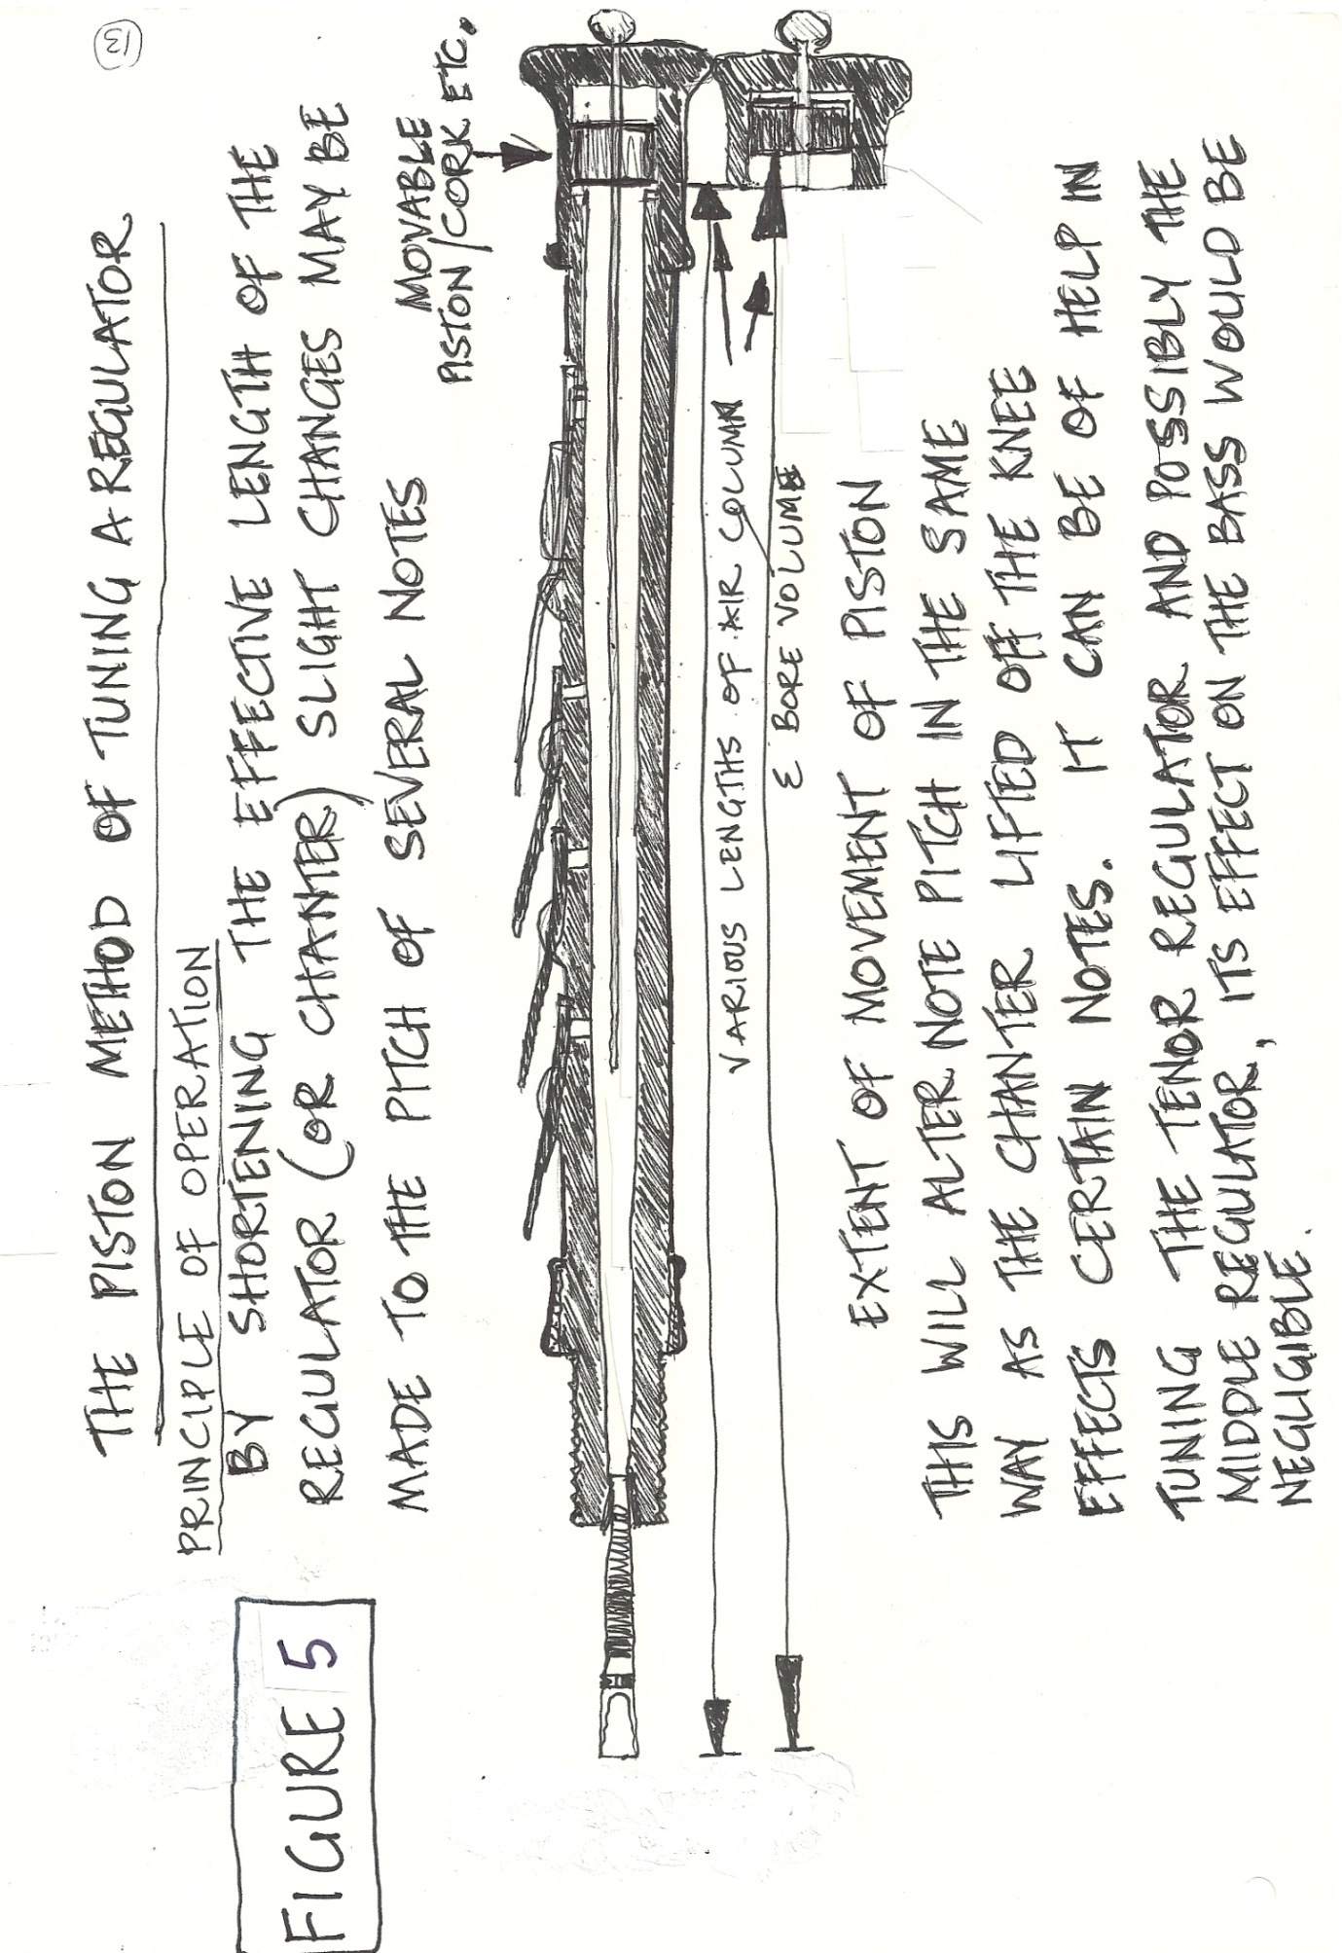

When Purchasing a New Set of Regulators.
When buying a set of pipes– get the maker to demonstrate that the regulators are in generally good tune and balance on all notes. It must be emphasized however that passing judgment on pipes cannot always be done quickly. Even very good sets can take a long time to get to know and to really get the best results in tuning and playing.
OTHER PLAYABILITY ISSUES AS REGARDS THE REGULATORS OF A FULL SET
There can be a variety of reasons why a set of regulators might not be playable to the satisfaction of a good performer. Such reasons might be
(a) Wear and tear or damage to a set.
(b) Bad adjustment or maintenance by the player.
(b) Workmanship problems which may have been there when the instrument was made.
COMMON WEAR AND TEAR/ WORKMANSHIP PROBLEMS
These can be considered together as they both require rectification before and realistic attempt can be made at learning to play the regulators.
Weak, too strong, or uneven springing of regulator keys will result in problems such as keys being too difficult to depress for the desired effect, especially rapid tipping of wrist chord keys.
Weakly sprung keys may also fail to return to close the note hole and any slight leaks in regulators will leave them impossible to tune and play until the problem is rectified.
Wobbly keys might be due to wear on the slots or the keys having been badly fitted. If the key will not always return the pad to its seating on the note hole, this may lead to leaks. It must be emphasised that leaking of air from the instrument is the greatest enemy of the piper. No chanter or regulator can play really well and with comfort if the instrument is leaking either from keys, finger holes, and stocks, bindings, tuning pin holes, bag, bellows and so forth. Even and controllable air pressure must be achieved if proper tuning and satisfactory tone are to be attained.
Systematic and Sequential Testing of Pipes Commencing at the Bellows
- DETECTION OF AIR LEAKS: If in doubt about possible air leaks, the instrument should be systematically and sequentially tested, commencing at the bellows and continuing until any possible leak is identified and rectified. The buyer of a set of pipes purported to be in playing condition should insist upon this being done before consenting to accept the set. However over time leaks may gradually develop around bag tying locations, key pads and valves. The player must watch for the development of leaks and set about putting them right. For description of this process see section 1 of these notes.
2. AVAILABILITY OF ALL OF THE HAND AND WRIST CHORDS. This might appear obvious but sets of pipes are seen from time to time which do not facilitate effective regulator playing. Examples of faults include:-
(a) Keys of uneven heights or shapes which leave certain wrist chord notes difficult to sound in rapid playing.
(b) Where pressing a regulator key this causes depression of the key above it, thus sounding a different and unwanted note.
(c) Other examples such as where the F# sharp note on the tenor regulator cannot be sounded in unison with the D note on the middle regulator or the F# on the middle regulator when depressed will lead to the accidental depression of the A on the bass regulator. Apart from inappropriate heights of different keys, misshaped keys can be a further occasional cause of some of these faults. Another example of a problem is the inability to sound G on the middle regulator while moving from the B key on the tenor regulator up to C natural key. SOMETIMES TURNING THE REGULATORS SLIGHTLY, AS MENTIONED IN SECTION 1 OF THESE NOTES, MAY SOLVE THIS PROBLEM.
(d) Regulators not fitted far enough into the stock or the lower regulator keys being possibly too short. This could make the lower wrist chords difficult or impossible to sound while both hands are engaged in playing the chanter. It must be remembered however that the longer, flatter pitched pipes are more difficult for playing regulators because firstly the chanter is longer with the regulating hand higher above the leg on which the instrument rests and secondly, as the regulators themselves are longer the keys are -
(i ) a bit further distant from the player, and
(ii) the top and bottom cross chords may further apart than with the more compact concert pitch sets.
(iii) The length of the bag neck. It is difficult to be specific about this point, except to mention that the neck must be long and flexible enough to allow the chanter to be effectively covered while enabling the player to reach and depress each regulator cross wrist chord. Some pipers are of the view that certain bag shapes make playing a bit easier or more comfortable. Big or awkwardly shaped bags can be a hindrance.
- ADJUSTMENT OF REGULATOR REEDS. As these can go out of tune they require regular attention to ensure that they are in good order. Regulator reeds should be capable of being sounded at chanter low and high octave pressures without the regulator notes jumping the octave or sounding falsely while being sounded with the chanter. The regulator player must be prepared to become familiar with adjusting reeds because these will go out of tune slightly from time to time and will require opening or closing, re-setting in the regulator, and the tuning pin and /or rush positions changed if necessary.

- THE CHANTER IS ALWAYS THE TUNING REFERENCE POINT. When the chanter is tuned and playing well and the regulator is out of tune - the regulator must be adjusted to suit the chanter. Reeds can go out of tune from time to time and in varying degrees, but the chanter reed, when playing well, should not be interfered with.

- UNIFORM REGULATOR REED PRESSURE. All regulator reeds must play at a uniform pressure. Individual pipers have their own preferences as regards regulator reed response, broadly speaking
some prefer thicker lipped reeds which are less open,
while others prefer thinner lipped reeds which are more open.
Regardless of the method preferred, the reeds must not jump the octave or fail to sound when the key is depressed.
Testing regulator reed pressure A test which can be done from time to time to check pressure uniformity is as follows:- If tenor and middle regulators are sounded with the chanter and the tenor sounds momentarily before the middle, then an adjustment must be made either to soften the middle or strengthen the tenor reed, depending upon which is considered necessary. To test, stop the chanter and depress a cross chord as lightly as possible and listen to find the reed which is too hard or too soft, and adjust accordingly. Experience gained over many weeks, months and years of playing and observation in different conditions is the only way of becoming skillful at this task. Periodic adjustment of rushes, blue tack, and even light sanding of reed lips will be necessary to keep the regulators in good tune. The ability to do this is what has led players to become masters of regulating as distinct from the skills of chanter playing.
- GETTING THE BODY OF THE INSTRUMENT IN THE MOST SUITABLE POSITION FOR PLAYING REGULATORS.
The set of pipes, while resting on the knee, tends to slide away from the player. It is a help to use of a string or belt tied from around the stock of the pipes and slung over the bag shoulder. This helps especially to reach the lower chords and allows return to the uppermost regulator keys. Seamus Ennis and Sean Seery were among the notables who used the shoulder strap and many modern players also find it necessary to reach lower chords especially for the longer flat pipes. It must also be mentioned that the height of the chair or seat can also have a bearing on the playing position. A chair is often better for playing regulators than the sitting-room sofa, which is sometimes too low down for playing comfort. Leo Rowsome's tutor emphasised the need for sitting in a relaxed, upright position. Bad posture should be avoided and the objective should be to be as much ease as possible when playing. To further help with regulator position some players lower the leg on which the set rests, keeping that knee lower than the other. They find it gives a more advantageous position for regulating. To summarise, use a string if it helps, and adjust it as necessary until you are fully satisfied that it is at the best length, then check your posture to ensure that by slight movement of the body all cross chords are obtainable while playing the chanter. Adjustment of stock and key positions. For ease of picking out chords and individual notes, the regulators need to be turned so that the keys are in the most suitable positions. In some cases the tenor regulator may be turned slightly towards the middle to facilitate simultaneous depression of pairs of tenor and middle regulator keys. It may also help to turn the main stock one way or the other to move the set of regulators so that either the tenor is high or alternatively, the bass is high to facilitate picking out individual regulator notes.
When all of these adjustments are done satisfactorily and possibly re-adjusted from time to time as experience is gained, the player will get much better at using the regulators of the pipes.
The late great Alain Froment who did so much to advance the quality of uilleann pipe making and went great trouble to ensure that his pipes met all functional and performance requirements as regards chanter, drones and regulators. A good exercise for testing out the use of hand chords and individual notes on the regulators was given to me by Alain when he wrote out the Castle of Dromore following Leo Rowsome’s arrangement. This air is worth using as a test and practice piece to verify tuning and develop regulator manipulation skills while playing the chanter simultaneously. He also emphasized the initial finger positions for hand chords and arpeggios and the hand sketch shows the fingers which he recommended as a first position for hand chords.
The Castle of Dromore played by Leo Rowsome is to be found on the Claddagh CD “The Drones & Chanters”. The melody is to be found in The Stanford-Petrie Complete Collection of Irish Music, Part 2 no. 509 and also in O Neill’s Music of Ireland , no. 52 but is set in the key of D. Alain’s transposition to the key of G which better suits the rich regulator harmonies and was the key which Leo used in his recording and arrangement.
THE SNOWY BREASTED PEARL
I find this is a very useful melody to play using combinations of hand and wrist chords, to test out the tuning and playability of a set of regulators and their balance with the chanter. Some of the progressions which Leo Rowsome gave in his Tutor and the very advanced musical devices which he demonstrated on his recording can serve to demonstrate the standard to which his pipes were made as regards playability and tenability.
Dave Hegarty

